My expectations for the Demo are:

# Create Branch from master (User Story)

# User can create branches.

1. User must be given access to Repository in User Permissions.

2. NOTE: While testing found that user has ability to map it to master or other branches.

Which shouldn't be the case. No work around found yet.

## EZ-Commit:

1.Please go to 'Admin > Salesforce Org Management > <Your Salesforce Org>' to map them.

2.Please go to 'Profile > My profile' to configure them

2. Update (User Story) branch with new changes

**Goto Ez Commit--> Select Org**

* Only changed/modified components are visible to select.

After selecting components, Select label Type =ALM System, Type = JIRA, Project ="Project as per sprint" and appropriate options for other selections.

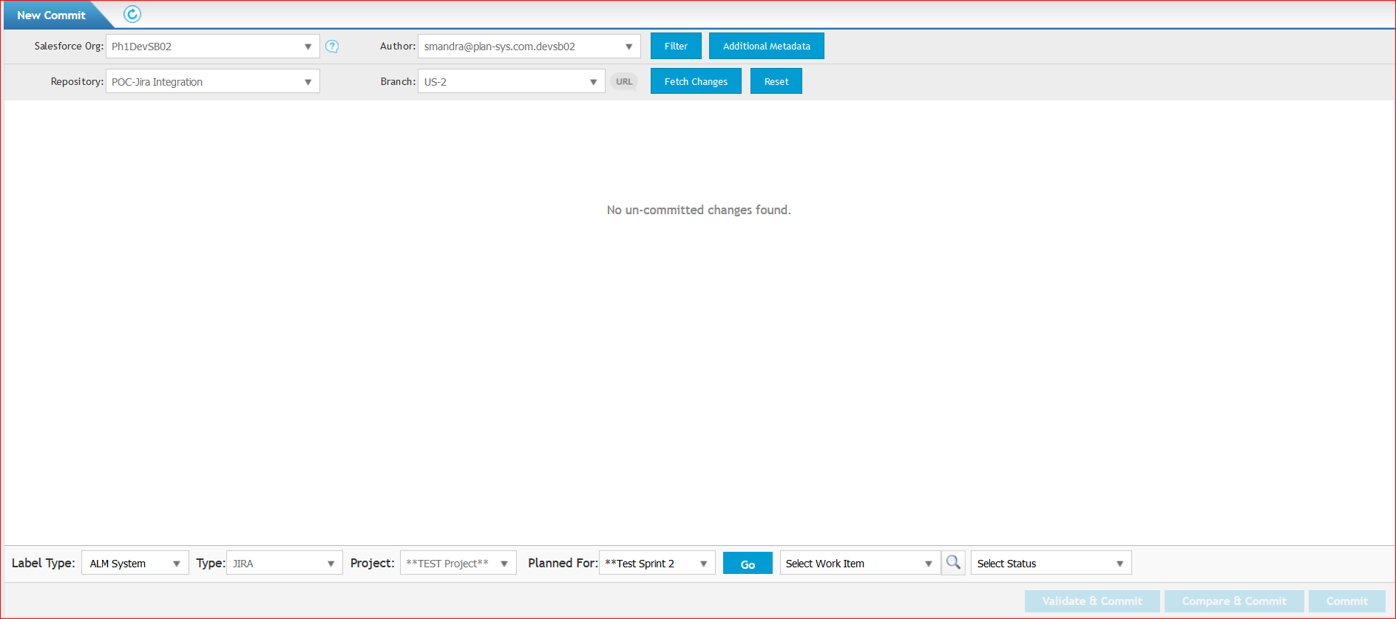

Choose Validate & Commit for others to review and deploy.

Choose Compare and commit to directly deploy without reviewing.

To deploy to a different user story branch. Change the mapping at org level to the branch.



2. Commit changes to master from Dev Sandbox development

Changes can be merged from new merge functionality.

3. Merge Branch and Deploy master to New Sandbox

4. See changes after Deployment in new sandbox

5. Rollback?????????????????

7. Merge and Deploy master to Sandbox again

8. See changes after deployment

From what I understand, this process needs to be solidified before automating which is where the AutoRabit and jira integration come into play.

Github needs to be integrated with Jira in order to display the commits made for the User Story. Steve and I can work with you to integrate that easily.